== checks for abstract equality eg true == 1

=== checks for strict equality eg 1 === 1

switch statements take a single expression/value as an input, and then look through a number of choices until they find one that matches that value
What is the syntax for a switch statement? -

switch (expression) {
case choice1:
run this code
break;

case choice2:
run this code instead
break;

// include as many cases as you like

default: // the default option runs if none of the choices match. you can safely omit it if there is no chance that the expression could end up equaling an unknown value. If there is a chance of this, however, you need to include it to handle unknown cases.
actually, just run this code
}

Here we've got:
- The keyword switch, followed by a set of parentheses.
- An expression or value inside the parentheses.
- The keyword case, followed by a choice that the expression/value could be, followed by a colon.
- Some code to run if the choice matches the expression.
- A break statement, followed by a semi-colon. If the previous choice matches the expression/value, the browser stops executing the code block here, and moves on to any code that appears below the switch statement.
- As many other cases (bullets 3–5) as you like.
- The keyword default, followed by exactly the same code pattern as one of the cases (bullets 3–5), except that default does not have a choice after it, and you don't need to break statement as there is nothing to run after this in the block anyway. This is the default option that runs if none of the choices match.

Write a function min(a,b) which returns the least of two numbers a and b
function min(a, b) {
if (a < b) {
return a;
} else {
return b;
}
}

What is the syntax for a ternary operator? -

( condition ) ? run this code : //first doesn’t match? Well → run this code instead

condition ? exprIfTrue : exprIfFalse
function min(a, b) {
return a < b ? a : b;
}

//this is the ? Method for the function question above

function ask(question, yes, no) {
if (confirm(question)) yes()
else no();
}

ask(
"Do you agree?",
function() { alert("You agreed."); },
function() { alert("You canceled the execution."); }
);

example of an anonymous functions accessible only inside of ask ()

function ask(question, yes, no) {
if (confirm(question)) yes()
else no();
}

ask(
"Do you agree?",
function() { alert("You agreed."); },
function() { alert("You canceled the execution."); }
);

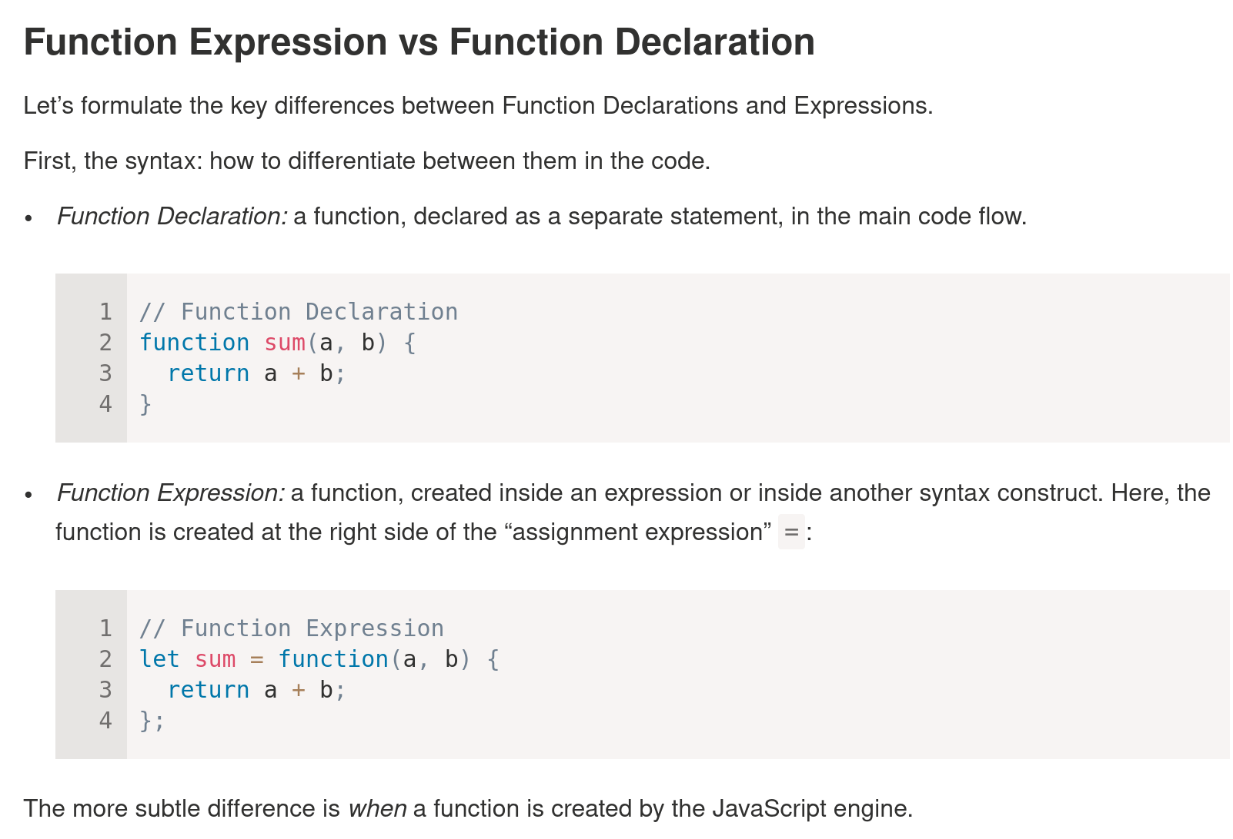
function expressions are created when the execution reaches it an then becomes usable

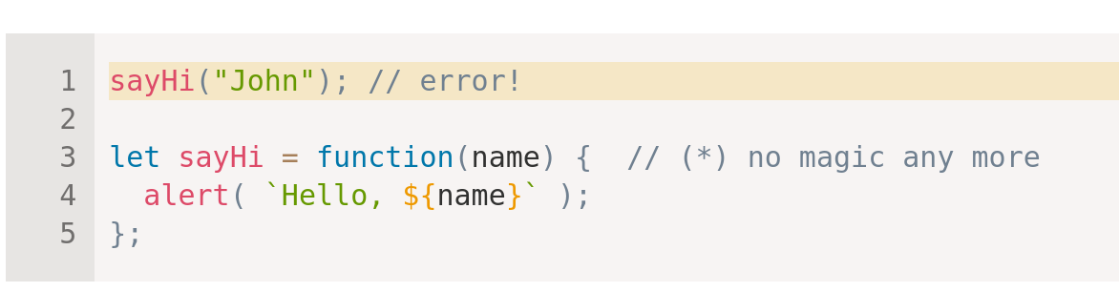

function declarations created (and usable)when JavaScript is preparing to start the script and is visible everywhere in it. Also of note they are only visible inside the code block in which it resides

a good way to remember this is - If the function is created as a part of an expression, it’s called a “Function Expression”.
- Function Declarations are processed before the code block is executed. They are visible everywhere in the block.

An example of an arrow function
